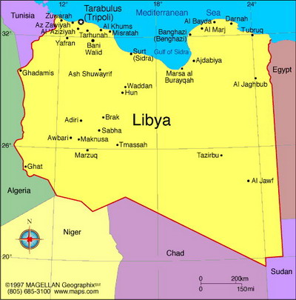
WANT TO KNOW TRUTH ABOUT LIBYA ?

Why bureaucrats and mediabosses all around the world
are up in arms against Kaddafi?

How can students from Tripoli, where "Internet is blocked" communicate via Skype with their friends abroad?
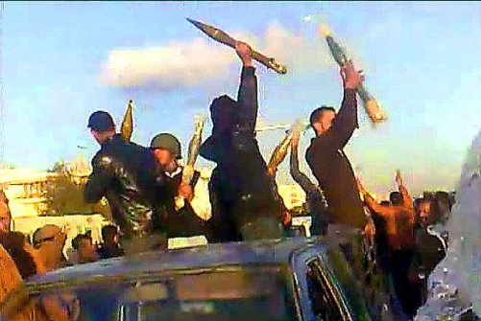  Why UN Security Council name these thugs with grenade launchers «peaceful manifestants»? | 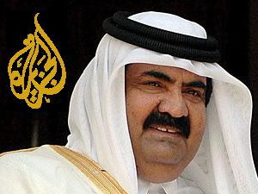  Who owns "Al-Jazeera"  and why they "do in" Kaddafi?  (Hint: the ruling family of Qatar is the main Libya’s rival at the gas market)
How come that the average earnings in Libya are higher than in Russia?
Why TV hasn’t broadcasted any mercenary soldier, any bomber pilot?
Who did the sewing of tens of monarchy banners for the "twitter manifestants"?
Who blocked the camp of Russian specialists in Ras-Lanouf?
The compensation of how many milliards Italy promised to Libya for the colonial war of the XXth century?
Why the state budget and the foreign policy is discussed at every local council in Libya?
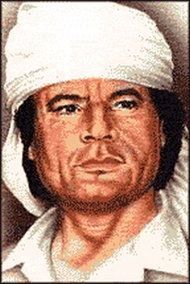  Why there are no paupers in Libya?  What did Kaddafi say to the leaders of the "G8" in the summer 2010?  Can a leader of revolution resign? | 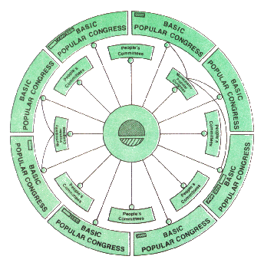  What does «Jamahiriya» mean and how does it work?
Follow KADDAFI.RU !

